RIDER UNITED VOICES 2019

RIDER:

1 Direct Box for Computer

6 Microphones with 7 Stands

1 Wireless Microphones

4 monitors

1 Keyboard,

Small Table to Set the Computer ON

6 Music Stands

7 Bottles of water

Snacks in Dressing Room, Sandwiches (Turkey no Ham); Fruit; Chips; Cookies; Juice

Hotel 4 stelle 6 rooms (2 doubles e 4 singles)
Dinner for 8 people

Voice

monitor

Voice

Voice

Voice

Voice

Voice

P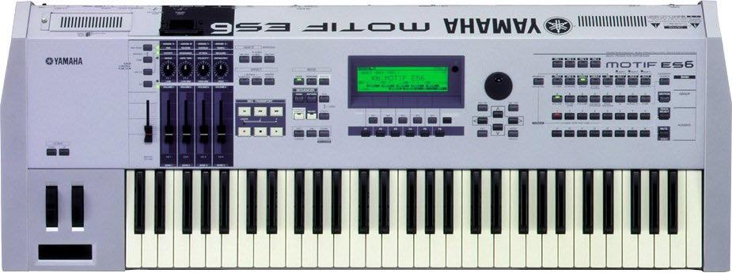IANO

monitor

monitor

monitor

Keyboards

